Question#1

Analysis between two countries Florida makes more profit then among all of them

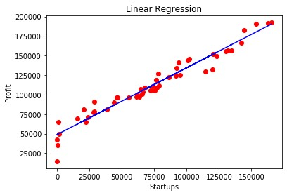

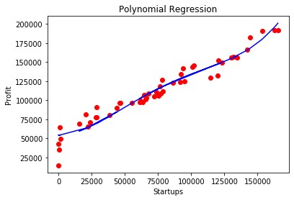

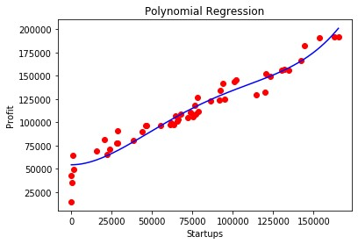

Question.2

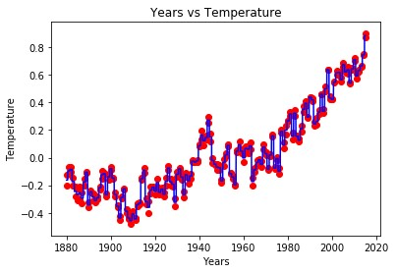

The prediction for 2016 & 2017 is [0.8845] & [0.8845] respectively.

Question.3

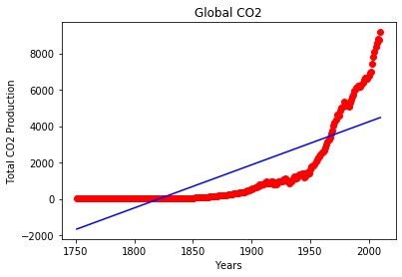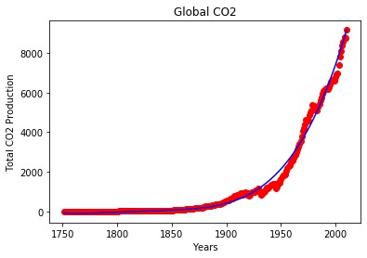

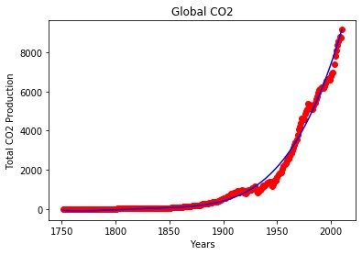

The prediction for year 2011 = [9340.0157637]

The prediction for year 2012 = [9532.40664323]

The prediction for year 2013 = [9727.79484826]

Question.4

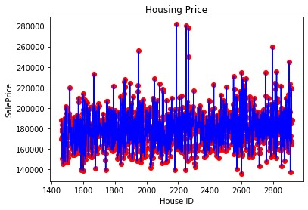

Question.5

